中北大学计算机与控制工程学院
实验报告
课程名称 面向对象程序设计 学号 学生姓名 辅导教师 韩慧妍
专业 | 计算机科学与技术 | 实验室名称 | 软件基础实验室 | 实验时间
1．实验名称
实验六 类的继承与派生
2. 实验目的
（1）学习定义和使用类的继承关系，定义派生类。
（2）熟悉不同继承方式下对基类成员的访问控制。
（3）学习利用虚基类解决二义性问题
3. 实验内容
（1）定义一个基类Animal，有私有整型成员变量age，构造其派生类dog，在其成员函数SetAge(int n)中直接给age赋值，看看会有什么问题，把age改为公有成员变量，还会有问题吗？编程试试看。
（2）定义一个车(vehicle)基类，具有MaxSpeed、Weight等成员变量，Run、Stop等成员函数，由此派生出自行车(bicycle)类、汽车(motorcar)类。自行车类有高度(height)等属性，汽车类有座位数(SeatNum)等属性。从bicycle和motorcar派生出摩托车(motorcycle)类，在继承过程中，注意把vehicle设置为虚基类。如果不把vehicle设置为虚基类，会有什么问题？编程试试看。
4. 实验原理或流程图
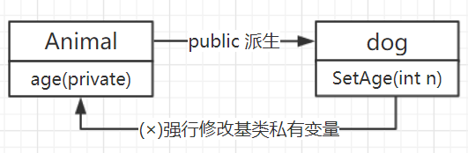

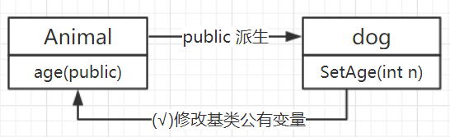

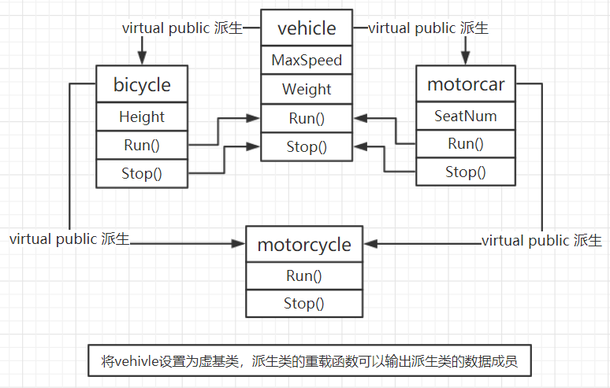
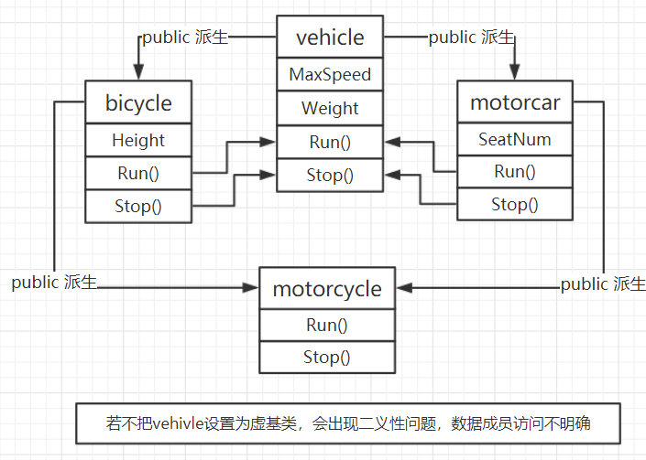

5. 实验过程或源代码
(1)
【Animal.h】
#include <iostream>
#include <string>
using namespace std;

class Animal
{
public:
Animal() { cout << "Animal constructor is called." << endl; }
~Animal() { cout << "Animal destructor is called." << endl; }

protected:
int age;
};

【dog.h】
#include "Animal.h"

class dog : public Animal
{
public:
dog() { cout << "dog constructor is called." << endl; }
~dog() { cout << "dog destructor is called." << endl; }
void SetAge(int n) { age = n; }
void print() { cout << "the dog age is " << age << endl; };
private:

};

【Main.cpp】
#include "dog.h"

int main()
{
dog d1;
d1.SetAge(15);
d1.print();
return 0;
}

(2)
【vehicle.h】
#include <iostream>
#include <string>
using namespace std;

class vehicle
{
public:
vehicle(int maxSpeed,double weight)
{
MaxSpeed = maxSpeed;
Weight = weight;
cout << "vehicle constructor is called." << endl;
}
~vehicle() { cout << "vehicle destructor is called." << endl; }

protected:
int MaxSpeed;
double Weight;
void Run() { MaxSpeed = 5; }
void Stop() { MaxSpeed = 0; }

};

【bicycle.h】
#include "vehicle.h"

class bicycle : virtual public vehicle
{
public:

bicycle(int maxSpeed, double weight, double height) :vehicle(maxSpeed, weight)
{
Height = height;
cout << "bicycle constructor is called." << endl;
}
~bicycle() { cout << "bicycle destructor is called." << endl; }
protected:
double Height;
void Run() { MaxSpeed = 20; }
void Stop() { MaxSpeed = 0; }
};

【motorcar.h】
#include "bicycle.h"

class motorcar : virtual public vehicle
{
public:
motorcar(int maxSpeed, double weight, int seatNum)
:vehicle(maxSpeed, weight),SeatNum(seatNum)
{
cout << "motorcar constructor is called." << endl;
}
~motorcar() { cout << "motorcar destructor is called." << endl; }
protected:
int SeatNum;
void Run() { MaxSpeed = 140; }
void Stop() { MaxSpeed = 0; }
};

【motorcycle.h】
#include "motorcar.h"

class motorcycle : public bicycle,public motorcar
{
public:
motorcycle(int maxSpeed, double weight, double height, int seatNum)
:vehicle(maxSpeed, weight), bicycle(maxSpeed, weight, height),
motorcar(maxSpeed, weight, seatNum)
{
cout << "motorcycle constructor is called." << endl;
}

void show()
{
cout << "MaxSpeed: " << MaxSpeed << "km/h"<< endl;
cout << "Weight: " << Weight << "kg" << endl;
cout << "Height: " << Height << "m" << endl;
cout << "SeadtNum: " << SeatNum << endl;
}
void Run() { MaxSpeed = 50; }
void Stop() { MaxSpeed = 0; }

~motorcycle() { cout << "motorcycle destructor is called." << endl; }
protected:

};

【Main.cpp】
#include "motorcycle.h"

int main()
{
motorcycle torcycle(0,150, 1.7, 3);
cout << "开车前：" << endl << endl;
torcycle.show();
torcycle.Run();
cout << "开车时：" << endl << endl;
torcycle.show();
torcycle.Stop();
cout << "停车后：" << endl << endl;
torcycle.show();
return 0;
}
6．实验结论及心得
（1）定义一个基类Animal，有私有整型成员变量age，构造其派生类dog，在其成员函数SetAge(int n)中直接给age赋值:
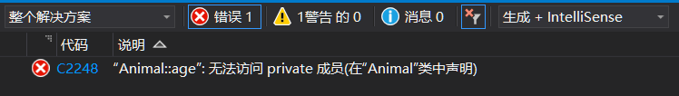
使用SetAge(int n)强行赋值私有变量

（2）把age改为公有成员变量后再通过SetAge(int n) 直接给age赋值:
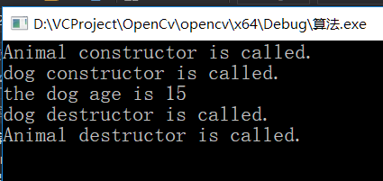
通过SetAge（int n）修改共有变量

（3）将vehicle设置为虚基类后正确的结果：

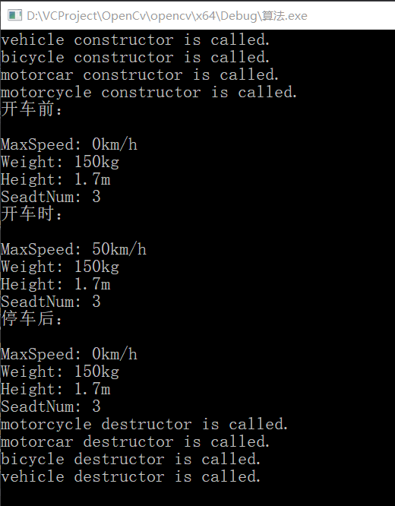

（4）如果不把vehicle设置为虚基类，会出现各种不明确的错误：

